CS 320 Project Two
Rebekah Frank

Each milestone included the creation and testing of the Contact, Task, and Appointment services. My approach with unit testing focused on validation of all functional requirements and enforcing certain input constraints. I used Junit 5 to implement systematic unit testing for both the model class and the associated service class.

For the Appointment service, I tested validation, setter validation, and service operations. An example of this is the Appointment constructor, which enforces constraints like ID length (10 character max), only allowing the use of future dates, and a description length (50 character max). In the AppointmentTest class, I verified these constraints using exception based testing:
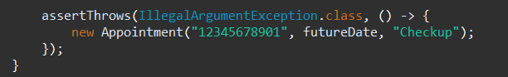
This test also ensures that the requirement limiting appointment ID length is enforced. In addition, I also tested temporal validation:
Using this made sure that past dates were rejected, aligning with the only future dates requirement.

For the Contact service, I tested all applicable field constraints including ID length, first and last name length, phone number validation, and address length. In ContactTest, I verified inputs using assertThrows. For example:
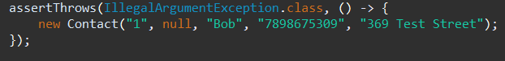
Using this confirms that null values are rejected as specified in the requirements. In ContactServiceTest, I also verified behavior like preventing duplicate IDs:
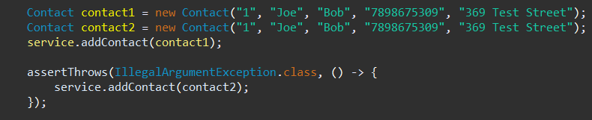

Finally, for the Task service, I validated ID lengths, name lengths, and description lengths. In the TaskTest class, I used boundary-based exception testing:
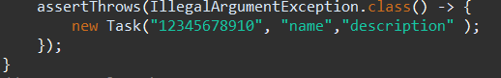
While in service-level tests in TaskServiceTest ensured tasks could be added, deleted and updated correctly, while preventing duped IDs. Example:
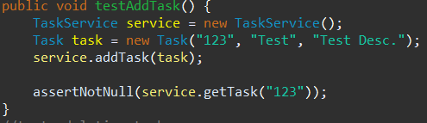

My testing approach aligned with the software requirements because every constraint listed was thoroughly tested. Each requirement equated to one test each. One such example of this can be a requirement as following:
Requirement: Phone number must be exactly 10 digits and contain no non-letters
→ Tested using invalid input "7898675a" in:
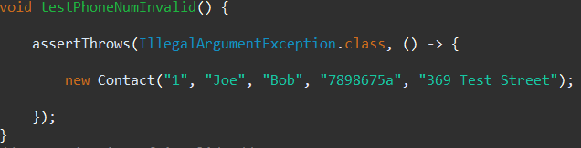
Direct traceability between requirements and tests demonstrates a strong alignment between specification and validation.

The quality of Junit tests can be evaluated based on both coverage and testing diversity. My tests cover the following:
- Constructor validation
- Setter validation
- Positive functionality
- Negative scenarios
- Service-layer logic
- Duplicate ID prevention
- Update operations
- Deletion operations
Since both model and services were tested, coverage extends to nearly all logical branches. Using assertThrows ensures that any invalid paths are also prevented, improving overall branch coverage.

The tests were effective because they covered both success and failure conditions. Having a balance between both ensures the application behaves as intended under any condition.
Writing the JUnit tests helped better an understanding of requirement-based validation and defensive programming techniques. Technical soundness was achieved by directly targeting validation logic within the constructors and setters. By isolating small units of functionality and avoiding unnecessary dependencies, I ensured efficiency. Additionally, by using in memory HashMap storage, lookup time was considerably short which made operations extremely efficient.
Overall I tested many different attributes (character length, valid vs invalid fields, and negative and positive testing). Of these, I did not utilize integration, performance, load, CI/CD automation, or mocking frameworks, as they were beyond the needs of the project, used local memory, and had no external dependencies. These testing methods are more appropriate for larger scale projects that have more components.
Using any testing methods as skipping validation can lead to data corruption, crashes, security issues, and long-term technical debt. Using strong test coverage circumvents these issues and is something I plan to continue using in the future.
References
Beizer, B. (1990). Software testing techniques. Van Nostrand Reinhold.
Jorgensen, P. C. (2013). Software testing: A craftsman’s approach (4th ed.). CRC Press.

